**CHAPTER-1**

**Introduction**

Face acknowledgment is significant to the use of Image preparation since it is utilized in different fields. It helps in the ID of people in any association with the end goal of participation in the board. Checking of participation and keeping up records assumes an essential job in the investigation of the presentation of the individuals from any association and the association all in all. The basic role of building up participation in the executive’s framework is to change from the conventional method of gauging participation to a more organized and productive technique. Robotized Attendance Management System plays out the everyday exercises of participation checking and investigation with decreased human mediation. The common strategies and approaches for identifying and perceiving faces neglect to defeat issues, for example, scaling, present, light, varieties, revolution, and impediments. The proposed framework intends to beat the entanglements of the current frameworks and gives highlights, for example, location of faces, extraction of the highlights, the discovery of separated highlights, and investigation of understudies' participation. The framework incorporates procedures, for example, picture contrasts, indispensable pictures, shading highlights, and falling classifiers for include location. The framework gives an expanded exactness because of the utilization of an enormous number of highlights (Shape, Color, LBP, wavelet, Auto-Correlation) of the face. Better exactness is accomplished in results as the framework considers the progressions that happen in the face over the timeframe and utilizes reasonable learning calculations.

In Face Detection and Recognition frameworks, the stream procedure begins by having the option to distinguish and perceive frontal countenances from an info gadget for example cell phone. In this day and age, it has been demonstrated that understudies connect better during addresses just when there is successful homeroom control. The requirement for elevated level understudy commitment is significant. A relationship can be made with that of pilots as depicted by Mundschenk et al (2011 p101)" Pilots need to stay in contact with an air traffic regulator, however, it would be irritating and unhelpful in the event that they brought in at regular intervals". Similarly, understudies should be persistently connected with during talks and one of the ways is to perceive and address them by their names. In my own view dependent on experience, during my time as an educator, I understood calling an understudy by his/her name gives me more control of the study hall and this attracts the consideration of different understudies the homeroom to draw in during addresses.

Face detection and recognition aren’t new in the general public we live in. The limit of the human psyche to perceive specific people is surprising. It is stunning how the human brain can in any case endure recognizable proof of specific people even through the progression of time, notwithstanding slight changes in appearance.

Anthony (2014 p1) reports that, because of the wonderful capacity of the human psyche to produce close to positive distinguishing proof of pictures and facial acknowledgment of people, this has drawn significant consideration for analysts to put the time in discovering calculations that will repeat powerful face acknowledgment on electronic frameworks for use by people.

**1.1 Motivation and Problem Definition**

This task is being done because of the worries that have been featured on the techniques which talks use to gauge participation during addresses. The utilization of clickers, ID cards swiping and physically recording names on a piece of paper as a technique to follow understudy chaperons have provoked this venture to be completed. This isn't in any capacity to scrutinize the different strategies utilized for understudy participation, yet to construct a framework that will distinguish the number of faces present in a study hall just as remembering them. Likewise, an educator will have the option to tell if an understudy was straightforward as these techniques referenced can be utilized by anybody for participation records, yet with the face identification and acknowledgment framework set up, it will be anything but difficult to discern whether an understudy is really present in the study hall or not.

This framework won't just improve study hall control during addresses, it will likewise conceivably distinguish faces for understudy participation purposes.

**CHAPTER-2**

**Literature Survey**

Face recognition has been considered for over 20 years, and it's still a lively subject owing to extensive practical applications. Automatic face recognition as a mean of human identification has been strongly experimented and reviewed for quite twenty-five years. Persons can be identified by their face, and face recognition is becoming possible because of the growths made within the computing capability over the past few years. Information security, law implementation, investigation, smart cards, access control are a number of the zones that have potential applications for Face Recognition. Last decade saw a fantastic amount of work finished this field.

**History of Face Recognition**

Table 2.1. A table showing the brief history of the prevailing face recognition techniques

|  |  |  |
| --- | --- | --- |
| **Years** | **Authors** | **Method** |
| 2019 | Chris Xiaoxuan Lu, Niki Trigoni, Andrew Markham, and John A. Stankovic | Deep Learning |
| 2017 | Xi Peng, Xiang, Dimitris N. Metaxas and Manmohan Chandraker Rutgers | Feature Learning |
| 2013 | Chaoyang Zhang, Fan Dong Zhaoxian Zhou and Hua Sun | Elastic Bunch Graph Matching (EBGM) and Linear Discriminate Analysis (LDA) and |
| 2001 | Viola & Jones | Adaboost + Haar Cascade |
| 1991 | Turk & Pentland | Eigenface |
| 1987 | Sirovich & Kirby | Principal Component Analysis (PCA) |

Chris Xiaoxuan Lu(et-al), 2019 used Ambient Wireless Cues approach during this work, they described Auto-Tune, a completely unique pipeline to simultaneously label face images within the wild and adapt a pre-trained deep neural network to acknowledge the faces of users in new environments.  
A key insight that motivates it's that enrolment effort of face labelling makes no sense if a the building owner get access to a wireless identifier, e.g. smart-phone’s MAC address.

Xi Peng (et-al), 2017 The State University of latest Jersey University of California, San Diego proposed a replacement reconstruction loss to regularize identity feature learning for face recognition.  
We also introduce a knowledge synthesization strategy to complement the range of pose, requiring no additional training data.

Chaoyang Zhang (et-al), 2013 used Linear Discriminant Analysis (LDA), Principal Component Analysis (PCA) and Elastic Bunch Graph Matching (EBGM) approach resulting detection accuracy was above 90% proved. Also Huan Liu used a Filter-based feature selection approach which resulted in high accuracy, 99%.

Viola(et-al), 2001 Haar cascade and Adaboost method comes together for new algorithms and insights to construct a framework for robust and very rapid visual detection. this technique was most clearly different from previous approaches in ability to detect faces extremely rapidly. Operating on 384 x 288-pixel images, faces were detected at 15 fps on 700MHz Intel Pentium 3 Processor.

Turk(et-al), 1991 discovered that using the Eigenfaces technique, the residual error could cause no facial detection in images, This discovery enabled the reliable and real-time automatic face recognition systems. Although this approach could be affected by environmental factors, it nonetheless create significant interest in further development of face recognition techniques..

Sirovich(et-al), 1987 used PCA. The Principal Component Analysis may be a standard linear algebra technique, to the face recognition problem, which showed that but 100 values were required to accurately point a suitably aligned and normalized facial image.

**CHAPTER-3**

**Methodology and Technology**

**Method**

**3.1 Face Detection**

Face detection is the way toward distinguishing and finding all the current appearances in a solitary picture or video paying little heed to their position, scale, direction, age and articulation.

Besides, the - recognition ought to be independent of unessential brightening conditions

what's more, the picture and video content.

A face Detector needs to tell whether a picture of subjective size contains a human face and if

in this way, where it is. Face discovery can be performed dependent on a few prompts: skin shading (for faces in shading pictures and recordings, movement (for faces in recordings), facial/head shape, facial appearance or a blend of these boundaries. Most face discovery calculations are appearance based without utilizing different prompts. An information picture is filtered at all conceivable areas and scales by a sub window. Location of the face acts as an ordering sub window as face or non face. The face/non-face classifier is found out from face and non-face preparing models utilizing factual learning strategies. Most present day calculations depend on the Viola Jones object discovery system, which depends on Haar Cascades.

**3.1.1 Haar – Cascades.**

Haar like features are rectangular examples in information. A course is a progression of "Haar-like features" that are joined to frame a classifier. A Haar wavelet is a scientific capacity that produces square wave yield.

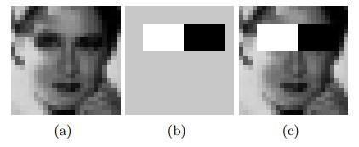

Figure 3.1.1.1 Haar like Features

Figure 3.1.1.1 shows Haar like features, the foundation of a format like (b) is painted dim to feature the example

Simply those pixels set apart in dim or white are used when the looking at feature is resolved. Since no target dispersion can depict the genuine earlier likelihood for a given picture to have a face, the calculation must limit both the bogus negative and bogus positive rates so as to accomplish an adequate presentation. This at that point requires a precise numerical depiction of what separates human countenances from different articles. Qualities that characterize a face can be removed from the pictures with a striking board of trustees learning calculation called Adaboost. Adaboost (Adaptive lift) depends on a board of trustees of feeble classifiers that consolidate to frame a solid one through a democratic component. A classifier is powerless if, in general, it can't meet a predefined order focus in blunder terms. The operational calculation to be utilized should likewise work with a sensible computational spending plan. Such procedures as the essential picture and attentional falls have made the Viola-Jones calculation exceptionally effective: took care of with an ongoing picture succession produced from a norm webcam or camera.

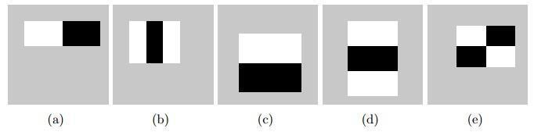

Figure 3.1.1.2 Haar-like features with different sizes and orientation

The size and position of an example's help can change given its high contrast square shapes have a similar measurement, fringe one another and keep their relative positions.

Because of this imperative, the quantity of features one can draw from a picture is fairly

reasonable a 24 X 24 picture, for example, has 43200, 27600, 43200, 27600 and 20736 features of class (a), (b), (c), (d) and (e) separately as appeared in Figure 3.3, subsequently 162336 features on the whole.

Practically speaking, five examples are thought of. The determined features are accepted to hold all the data expected to describe a face. Since faces are enormous and normal ordinarily, the utilization of Haar-like examples appears to be advocated.

**3.1.2 How the Haar – like Features Work**

A scale is picked for the features let’s state as 24 × 24 pixels. This is then slid over the picture. The normal pixel esteems under the white territory and the dark zone are then processed. In the event that the contrast between the territories is over some edge then the component matches.

In face location, since the eyes are of various shading tone from the nose, the Haar include

(b) from Figure 3.3 can be scaled to fit that zone as demonstrated as follows,

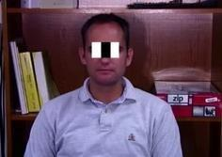

*Figure 3.1.2.1 How the Haar like feature of Figure 3.1.1 can be used to scale the eyes*

One Haar feature is anyway insufficient as there are a few features that could coordinate it (like the compressed memory drive and white zones at the foundation of the picture). A solitary classifier thus it isn't sufficient to coordinate all the features of a face, it is known as a "weak classifier."

Haar cascades, the premise of Viola Jones location structure in this way comprise a progression of weak classifiers whose precision is in any event half right. In the event that a zone passes a weak classifier, it moves to the following weak classifier, etc, something else, the region doesn't coordinate.

**3.1.3 Cascaded Classifier**

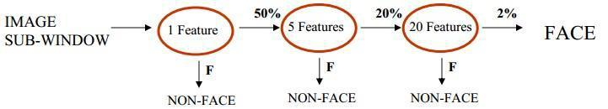

*Figure 3.1.3.1. several classifiers combined to enhance face detection*

From Figure 3.1.2.1, a 1 feature classifier accomplishes 100% face recognition rate and about half bogus positive rate. A 5 feature classifier accomplishes 100% identification rate and 40% bogus positive rate (20% aggregate). A 20 element classifier accomplishes 100% identification rate with 10% bogus positive rate (2% cumulative).Combining a few weak classifiers improves the precision of recognition. A preparation calculation called Adaboost, short for versatile boosting, which had no application before Haar falls, was used to consolidate a progression of weak classifiers in to a strong classifier.

Adaboost evaluates numerous weak classifiers more than a few rounds, choosing the best powerless classifier in each round and consolidating the best weak classifier to make a strong classifier. Adaboost can utilize classifiers that are reliably off-base by switching their choice. In the structure and improvement, it can take a long time of preparing effort to decide the last

course succession. After the last course had been developed, there was a requirement for a way to rapidly figure the Haar features for example figure the distinctions in the two territories. The fundamental picture was instrumental in this.

**3.1.4 Integral Image**

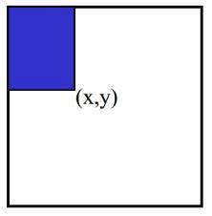

*Figure 3.1.4.1. Pixel Coordinates of an integral image*

The Integral picture otherwise called the "added territory table" created in 1984 came in to broad use in 2001 with the Haar falls. An added region table is made in a solitary pass. This makes the Haar falls quick, since the aggregate of any area in the picture can be figured utilizing a solitary equation.

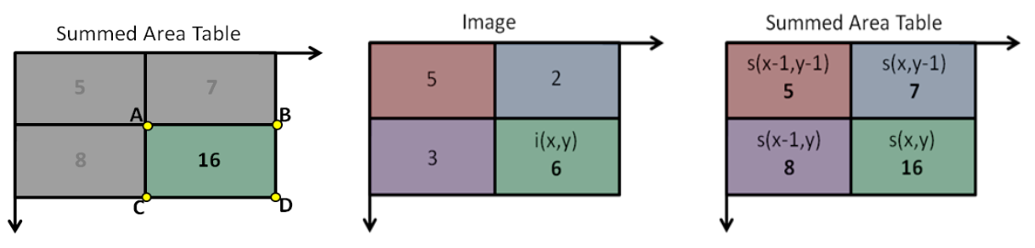

*Figure 3.1.4.2 Integral image calculation.*

The fundamental picture processes an incentive at every pixel (x, y) as is appeared in Figure 3.6, that is the whole of the pixel esteems above and to one side of (x, y), comprehensive. This can rapidly be processed in one go through the picture.

Let A, B, C D be the estimations of the indispensable picture at the edges of a square shape as appeared in Figure 3.1.4.2.

Just three increases are required for any size of square shape. This face recognition approach limits calculation time while accomplishing high identification precision. It is presently utilized in numerous regions of PC vision.

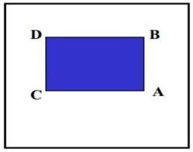

. *Figure 3.1.4.3. Values of the integral Image on a rectangle*

**3.1.5 Improving Face Detection**

Face detection can be improved by tuning the detectors parameters to yield satisfactory results. The parameters to be adjusted are explained as follows

**3.1.5.1Scale Increase Rate.**

The scale increment rate indicates how rapidly the face indicator capacity should expand the scale for face discovery with each disregard it makes a picture. Setting the scale increment rate high makes the finder show quicker to running less passes. On the off chance that it is set too high it might bounce immediately between the scales and miss the countenances. The default increment rate in OpenCV is 1.1. This infers the scale increments by a factor of 10 % each pass. The boundaries expect an estimation of 1.1, 1.2, 1.3 or 1.4.

**3.1.5.2 Minimum Neighbors Threshold**

The base neighbor's threshold sets the cut-off level for disposing of or keeping square shape bunches as either faces or not. This depends on the quantity of crude recognition in the gathering and its qualities ranges from zero to four.

At the point when the face identifier is called in the background, every positive face area produces numerous hits from the Haar locator as in Figure 3.8. The face locale itself produces an enormous bunch of square shapes to a huge expanded cover. The separated discoveries are normally bogus discoveries and are disposed of. The numerous face district discoveries are then converged into a single identification. The face recognition work does this before restoring the rundown of the recognized countenances. The union advances square shapes that contain countless covers and afterward finds the normal square shape for the gathering. It at that point replaces all the square shapes in the bunch with the normal square shape.

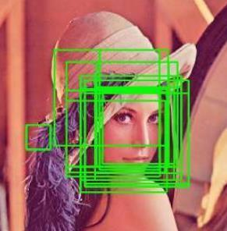

*Figure 3.1.4.4 Lena’s image showing the list of rectangles*

**3.1.5.3 Minimum Detection Scale**

This location boundary sets the size of the littlest face that can be looked in the info picture. The most generally utilized size is 24 × 24. Contingent upon the goal of the info picture, the little size might be a little segment of the info picture. This would then not be supportive as its location would take up Central Processing Unit (CPU) cycles that could have been used for different purposes.

**3.2 Face Recognition**

Face Recognition is a visual example acknowledgment issue, where the face, spoke to as a three dimensional item that is liable to differing brightening, present and different variables,

should be distinguished depending on procured pictures. Face Recognition is in this way basically the assignment of distinguishing a previously recognized face as a known or obscure face and in additional propelled cases telling precisely whose face it is.

Although various methodologies have been attempted by a few gatherings of individuals over the world to take care of the issue of face acknowledgement, no specific strategy has been found that yields acceptable outcomes in all conditions.

**3.2.1 Convolution Neural Network (CNN)**

In neural systems, Convolutional neural system (ConvNets or CNNs) is one of the fundamental

classifications to do pictures acknowledgment, pictures orders. Items discoveries, acknowledgment faces and so forth., are a portion of the territories where CNNs are broadly utilized. CNN picture groupings takes an info picture, process it and characterize it under specific classes (Eg., Dog, Cat, Tiger, Lion). PCs consider a to be a picture as an exhibit of pixels and it relies upon the picture goal. In view of the picture goal, it will see h x w x d( h = Height, w = Width, d = Measurement ). Eg., A picture of 6 x 6 x 3 cluster of lattice of RGB (3 alludes to RGB values) what's more, a picture of 4 x 4 x 1 cluster of lattice of grayscale pictures.

In fact, profound learning CNN models to prepare and test, each information picture will pass it through a progression of convolution layers with channels (Kernels), Pooling, completely associated layers (FC) and apply Softmax capacity to group an article with probabilistic qualities between 0 furthermore, 1. The beneath figure is a finished progression of CNN to process an info picture and groups the items dependent on values.

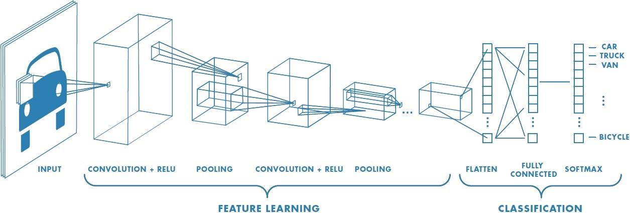

Figure 3.2.1.1 : Neural network with many convolutional layers

**3.2.1.1 Convolution Layer**

Convolution is the primary layer to extricate features from an info picture. Convolution jam the connection between pixels by learning picture features utilizing little squares of info information. It is a scientific activity that takes two information sources, for example, picture framework and a channel or part.

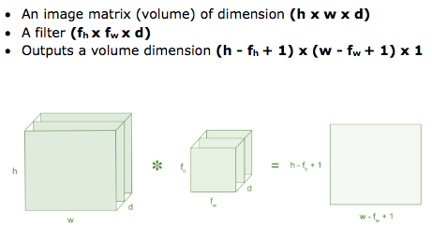

Figure 3.2.1.1.1: Image matrix multiplies kernel or filter matrix

Consider a 5 x 5 whose picture pixel esteems are 0, 1 and channel framework 3 x 3 as appeared in underneath

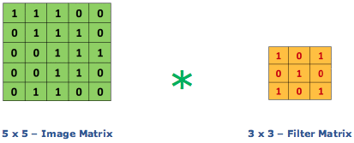

Figure 3.2.1.1.2: Image matrix multiplies kernel or filter matrix

At that point the convolution of 5 x 5 picture lattice duplicates with 3 x 3 channel grid which is called "**feature Map**" as yield appeared below



Figure 3.2.1.1.3: 3 x 3 Output matrix

Convolution of a picture with various channels can perform tasks, for example, edge location, obscure and hone by applying channels. The beneath model shows different convolution picture

in the wake of applying various kinds of channels (Kernels). Step is the quantity of pixels shifts over the information lattice. At the point when the step is 1 then we move the channels to 1 pixel at once. At the point when the step is 2 then we move the channels to 2 pixels at a

time, etc. The underneath figure shows convolution would work with a step of 2.

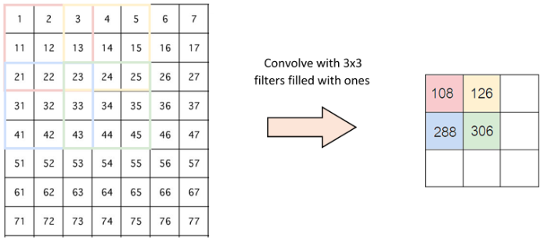

Figure 3.2.1.1.4: Stride of 2 pixels

**3.2.1.2 Padding**

Now and then the filter doesn't completely fit the information picture. We have two alternatives:

* Cushion the image with zeros (zero-cushioning) so it fits
* Drop the piece of the picture where the channel didn't fit. This is called legitimate cushioning which keeps just a substantial piece of the picture.

**3.2.1.3 Non Linearity (ReLU)**

ReLU represents a Rectified Linear Unit for a non-direct activity. The yield is **ƒ(x) = max(0,x)**.

Why ReLU is significant : ReLU's motivation is to present non-linearity in our ConvNet. Since, this present reality information would need our ConvNet to learn would be non-negative direct qualities.

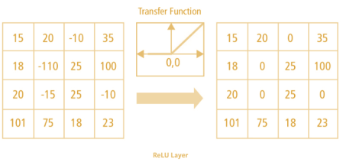

Figure 3.2.1.3.1 : ReLU operation

There are other non straight capacities, for example, tanh or sigmoid that can likewise be utilized rather than ReLU. The greater part of the information researchers use ReLU since execution shrewd ReLU is superior to the next two.

**3.2.1.4 Pooling Layer**

Pooling layers segments would diminish the quantity of boundaries when the pictures are excessively huge. Spatial pooling likewise called subsampling or downsampling which diminishes the dimensionality of each guide yet holds significant data. Spatial pooling can be of various kinds:

* Max Pooling
* Average Pooling
* Sum Pooling

Max pooling takes the biggest component from the corrected element map. Taking the biggest component could likewise take the Average Pooling. Total of all components in the element map call as Sum Pooling.

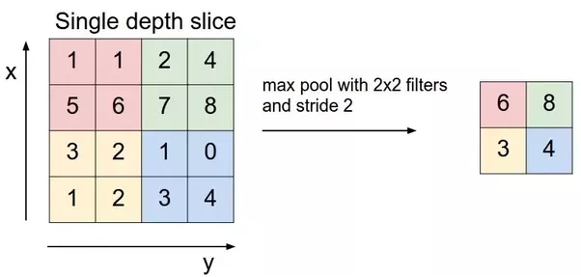

Figure 3.2.1.4 : Max Pooling

**3.2.1.5 Fully Connected Layer**

The layer we call as FC layer, we flattened our matrix into vector and feed it into a fully connected layer like a neural network.

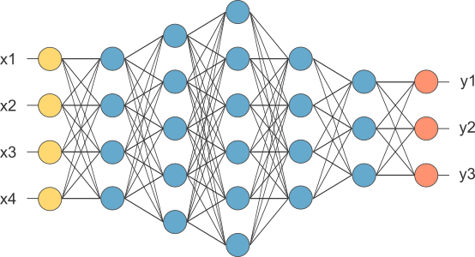

Figure 3.2.1.5 : After pooling layer, flattened as FC layer

In the above graph, the element map framework will be changed over as a vector (x1, x2, x3, … ). With the completely associated layers, we consolidated these highlights together to make a model. At long last, we have an initiation capacity, for example, softmax or sigmoid to arrange the yields as feline, canine, vehicle, truck and so forth.,  
**3.3 System Architecture**

The Figure below shows the logical design and implementation of the three desktop subsystems

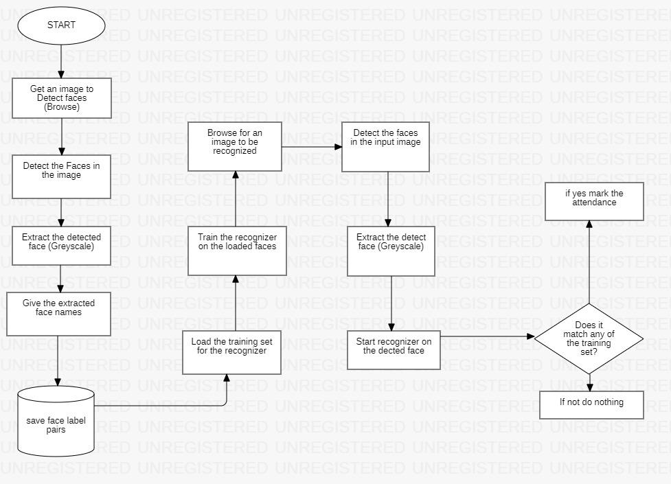

Figure 3.3.1. Sequence of events in the class attendance system.

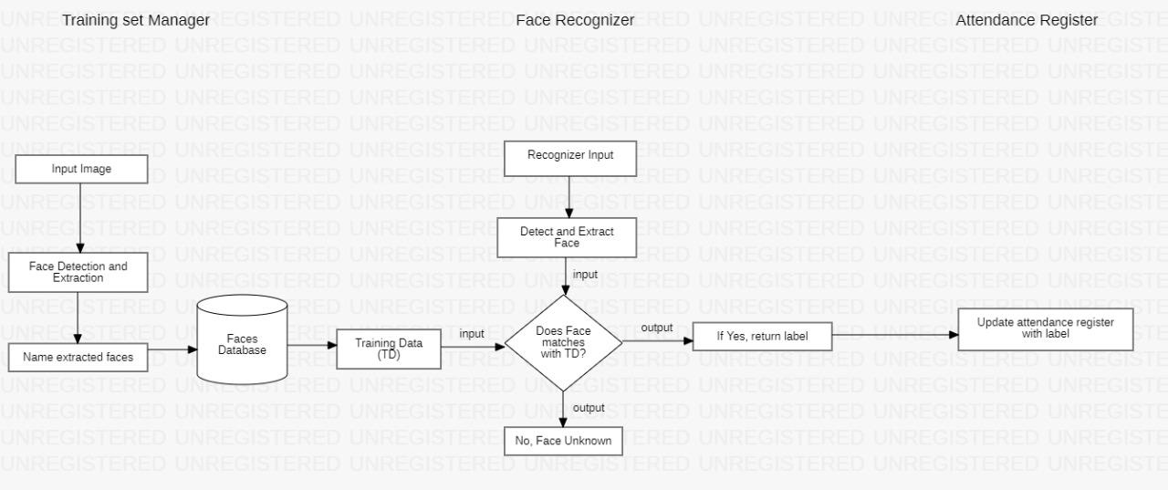

Figure 3.3.2. The logical design of the Desktop Module Subsystems

**CHAPTER-4**

**Conclusions and Future Work**

**Conclusion:**

This system is developed for maintaining the attendance record. The main motive behind developing this system is to eliminate all the drawbacks, which were associated with manual attendance system. The drawbacks ranging from wastage of time and paper, till the proxy issues arising in a class, are eliminated. Hence, desired results with user-friendly interface is expected in the future, from the system. The efficiency of the system could also be increased by integrating various steps and techniques in the future developing stages of the system

**Future Work:**

The work has implemented a face recognition system by using PCA which is eigenvector based multivariate analyses. Often, its operation can be thought of as revealing the internal structure of the data in a way which best explains the variance in the data. By implementing PCA the proposed Face Recognition System supplies the user with a lower dimensional picture, a "shadow" of this object when viewed from its most informative viewpoint. The algorithm has been tested with multiple students in the scene and also captured faces at different angles in the scene. The algorithm delivers quite good results but there is a room to improve the algorithm performance in case of large number of students and also in case of faces captured in a dark environment, so proposed system can be extended in the future to cover this aspect. The efficiency of the algorithm also can be increased further so there is also a room for future work in this area. This system can be enhanced further in terms of achieving more efficiency by ease of analysis of patterns in the data.

**PROGRESS REPORT VII SEMESTER**

|  |  |
| --- | --- |
|  | **Brief Description of Work** |
| First Review | Requirement Gathering and analysis |
| Second Review | Software Requirement Analysis |
| Third Review | Design |
| Final Review | Coding and Implementation |

**PROGRESS REPORT VIII SEMESTER**

|  |  |
| --- | --- |
|  | **Brief Description of Work** |
| First Review | Integration and Testing |
| Second Review | Deployment of system |
| Third Review | Maintenance with some changes |
| Final Review | Final report generation |

**References**

[1] M. Turk, A. Pentland, Eigenfaces for Recognition, Journal of Cognitive Neuroscience, Vol. 3, No. 1, Win. 1991, pp. 71-86.

[2] C. Kotropoulos and I. Pitas, “Rule-based face detection in frontal views,” Proc. Int’l Conf. Acoustics, Speech and Signal Processing, vol. 4, pp. 2537-2540, 1997.

[3] E. Saber and A.M. Tekalp, “Frontal-view face detection and facial feature extraction using color, shape and symmetry based cost functions,” Pattern Recognition Letters, vol. 17, no. 8, pp. 669-680, 1998.

[4]Face Recognition Using Line Edge Map Yongsheng Gao, Member, IEEE, and Maylor K.H. Leung, Member, IEEE (IEEE TRANSACTIONS ON PATTERN ANALYSIS AND MACHINE INTELLIGENCE, VOL. 24, NO. 6, JUNE 2002) 28.

[5] Discriminant analysis for recognition of human face images Kamran Etemad and Rama Chellappa.

[6] Sanjay singh et.al, “A robust skin color based face detection algorithm”, Tamkang Journal of Science and Engineering vol.6, no.4,pp227-234, 2003.

[7] OpenCV. Available: http://sourceforge.net/projects/ opencv library/.

[8] Activity zones for context-aware computing, Lecture Notes in Computer Science, Volume 2864/2003, pp. 90-106, 2003.

[9] Z. Zhou, X. Chen, Y. â“C. Chung, Z. He, T. X. Han, and J. M. Keller, "Activity analysis,summarization, and visualization for indoor human activity monitoring,â IEEE Transactions on Circuits and Systems for Video Technology, Volume 18, Issue 11, pp. 1489- 1498, 2008.

[10] Jose M.Chaves-Gonzalez, Miguel A Vega-Rodríguez,Juan A.Gomez-Pulido,Juan M.Sanchez-perez,” Detecting skin in face recognition systems: A color spaces study”, Digital signal processing, 20(2010) 806-823.

[11] Technical Paper on â_ Image Based Intelligent Attendance Logging System, IEEE Technical Paper by Hary Oktavianto, Hsu Gee-Sern Chung Sheng-Luen, June 30-July 2, 2012, Dalian,China.

[12]International Journal of Information Technology and Knowledge Management JulyDecember 2012, Volume 5, No. 2, pp. 361-3639(Face Recognition Techniques: Classification and Comparisons).

[13]Face Recognition using Line Edge Map Vipin Kumar and Mohit Mehta Department of Electronics and communication, Punjab College of engineering and technology, India Accepted 01 January 2014, Available online 10 January 2014, Vol.2 (Jan/Feb 2014 issue).

[14]International Journal of Computer Applications (0975-8887) Volume 98-No.20,July 2014(Adjacency Matrix based Face Recognition Approach).

[15]International Journal of Advanced Computer Research (ISSN (Print): 2249-7277 ISSN (Online): 2277-7970) Volume-4 Number-4 Issue-17 December-2014 939 Study of Face Recognition Techniques Sangeeta Kaushik1*, R. B. Dubey2 and Abhimanyu Madan3.

[16]International Journal of Innovative Research in Computer and communication Engineering(Vol.3,Issue 8,Aug 2015)(Automated Attendance System Using Face Recognition).